SCHOOL OF COMPUTER SCIENCE AND ARTIFICIAL INTELLIGENCE |  |  |  |  | DEPARTMENT OF COMPUTER SCIENCE ENGINEERING
Program Name: B. Tech |  |  |  | Assignment Type: Lab |  |  | Academic Year:2025-2026
Course Coordinator Name |  |  |  | Venkataramana Veeramsetty
Instructor(s) Name |  |  |  | Dr. V. Venkataramana (Co-ordinator)  Dr. T. Sampath Kumar  Dr. Pramoda Patro  Dr. Brij Kishor Tiwari  Dr.J.Ravichander  Dr. Mohammand Ali Shaik  Dr. Anirodh Kumar  Mr. S.Naresh Kumar  Dr. RAJESH VELPULA  Mr. Kundhan Kumar  Ms. Ch.Rajitha  Mr. M Prakash  Mr. B.Raju  Intern 1 (Dharma teja)  Intern 2 (Sai Prasad)  Intern 3 (Sowmya)  NS_2 ( Mounika)
Course Code |  |  | 24CS002PC215 | Course Title |  | AI Assisted Coding
Year/Sem |  |  | II/I | Regulation |  | R24
Date and Day  of Assignment |  |  | Week6 - Monday | Time(s)
Duration |  |  | 2 Hours | Applicable to  Batches
AssignmentNumber:11.1(Present assignment number)/24(Total number of assignments)
 | Q.No. | Question |  |  |  |  |  | Expected Time  to complete
 | 1 | Lab 11 – Data Structures with AI: Implementing Fundamental Structures  Lab Objectives  - Use AI to assist in designing and implementing fundamental data structures in Python.  - Learn how to prompt AI for structure creation, optimization, and documentation.  - Improve understanding of Lists, Stacks, Queues, Linked Lists, Trees, Graphs, and Hash Tables.  - Enhance code quality with AI-generated comments and performance suggestions.  Task Description #1 – Stack Implementation  Task: Use AI to generate a Stack class with push, pop, peek, and is_empty methods.  Sample Input Code:  class Stack:  pass  Expected Output:  - A functional stack implementation with all required methods and docstrings.  Prompt : Write a python code in terms of stack class using is_empty methods and also like push,pop,peek .Take input from the user.  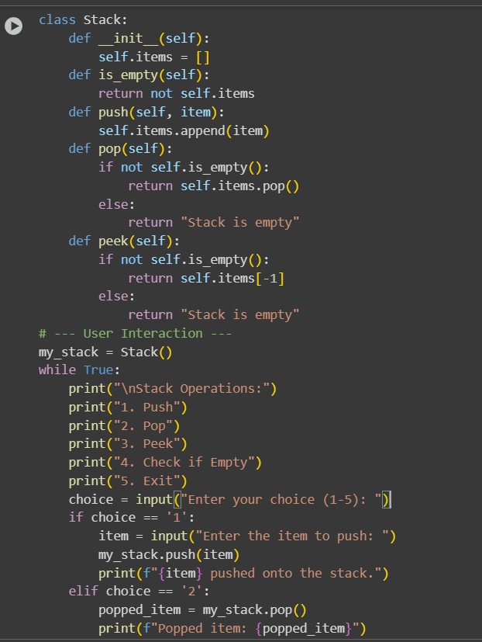  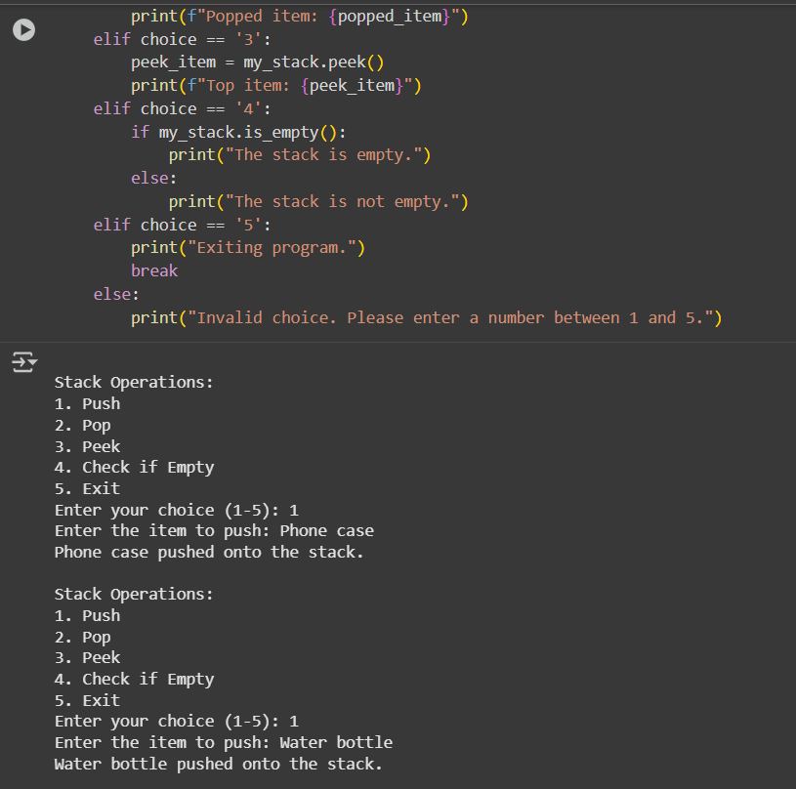  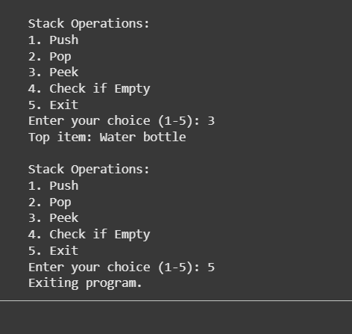  Task Description #2 – Queue Implementation  Task: Use AI to implement a Queue using Python lists.  Sample Input Code:  class Queue:  pass  Expected Output:  - FIFO-based queue class with enqueue, dequeue, peek, and size methods.  Prompt : Write a python code to generate queue class which is of fifo based with enqueue , dequeue , peek and size methods  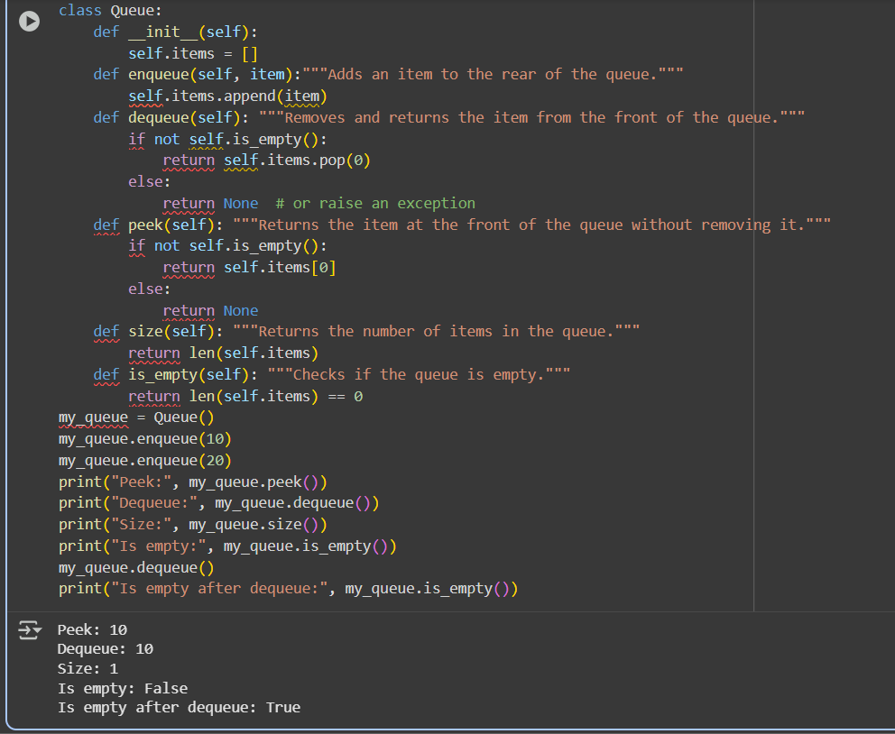  Task Description #3 – Linked List  Task: Use AI to generate a Singly Linked List with insert and display methods.  Sample Input Code:  class Node:  pass  class LinkedList:  pass  Expected Output:  - A working linked list implementation with clear method documentation.  Prompt : Write a python code to generate a single linked list by inserting and display methods . The output should consists of linked list implementation with clear method documentation.  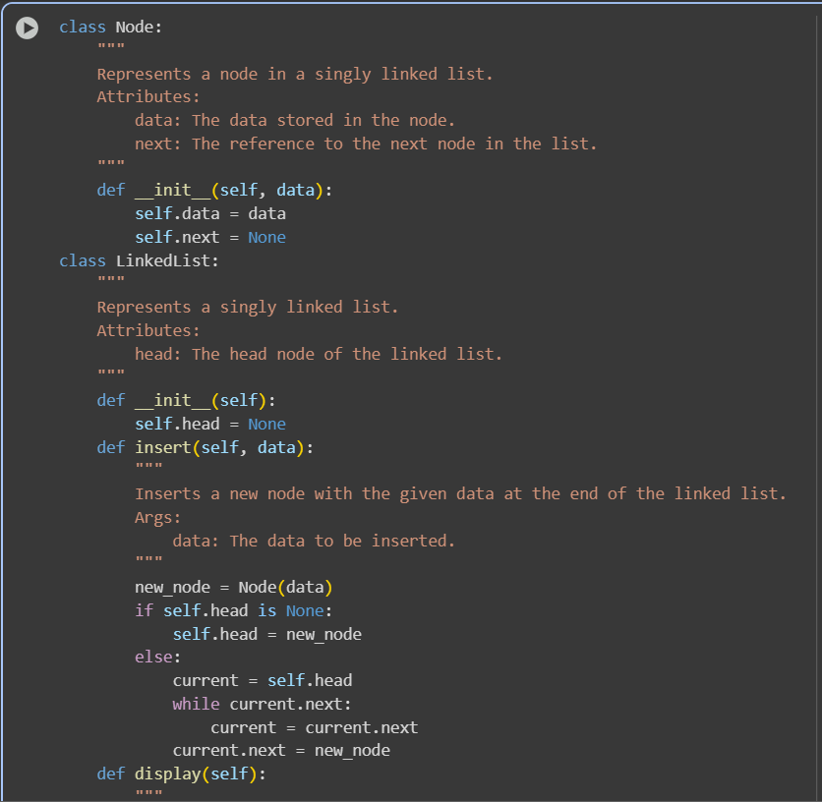  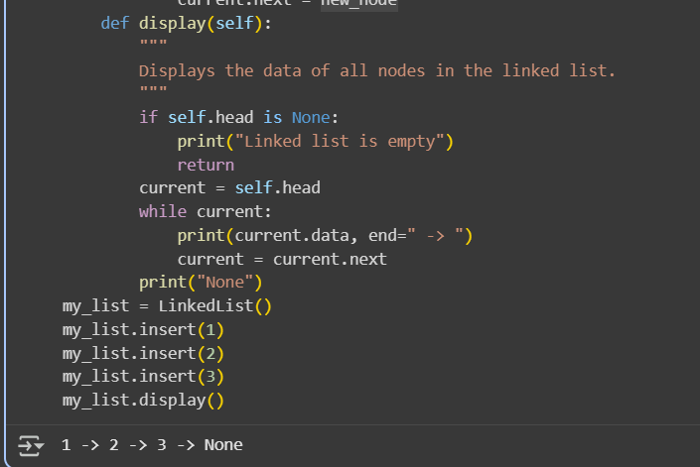  Task Description #4 – Binary Search Tree (BST)  Task: Use AI to create a BST with insert and in-order traversal methods.  Sample Input Code:  class BST:  pass  Expected Output:  - BST implementation with recursive insert and traversal methods.  Prompt : Write a python code to create a binary search tree with insert and in order traversal methods . Take input from user and the output should consisy of implementation with recursive insert and traversal methods.  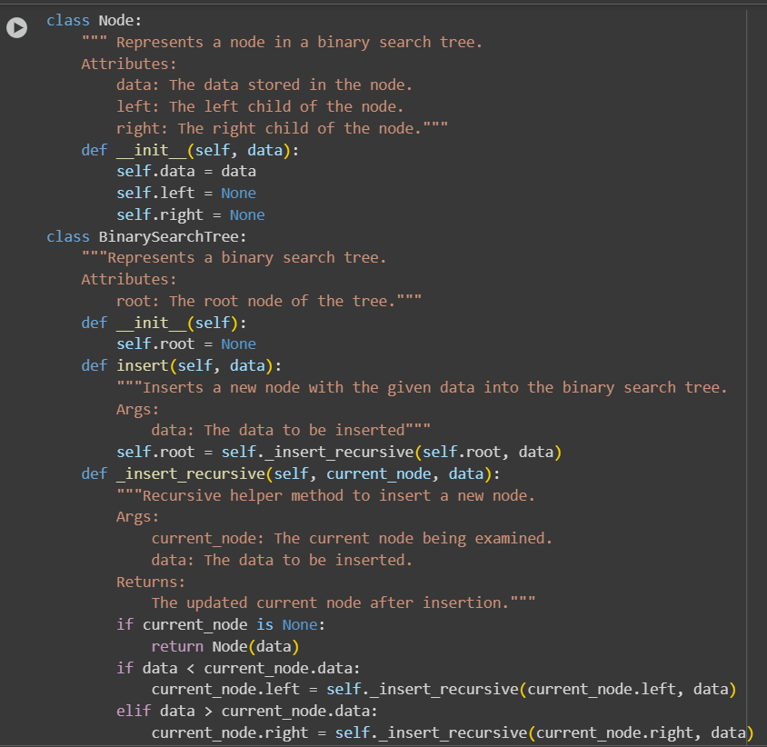  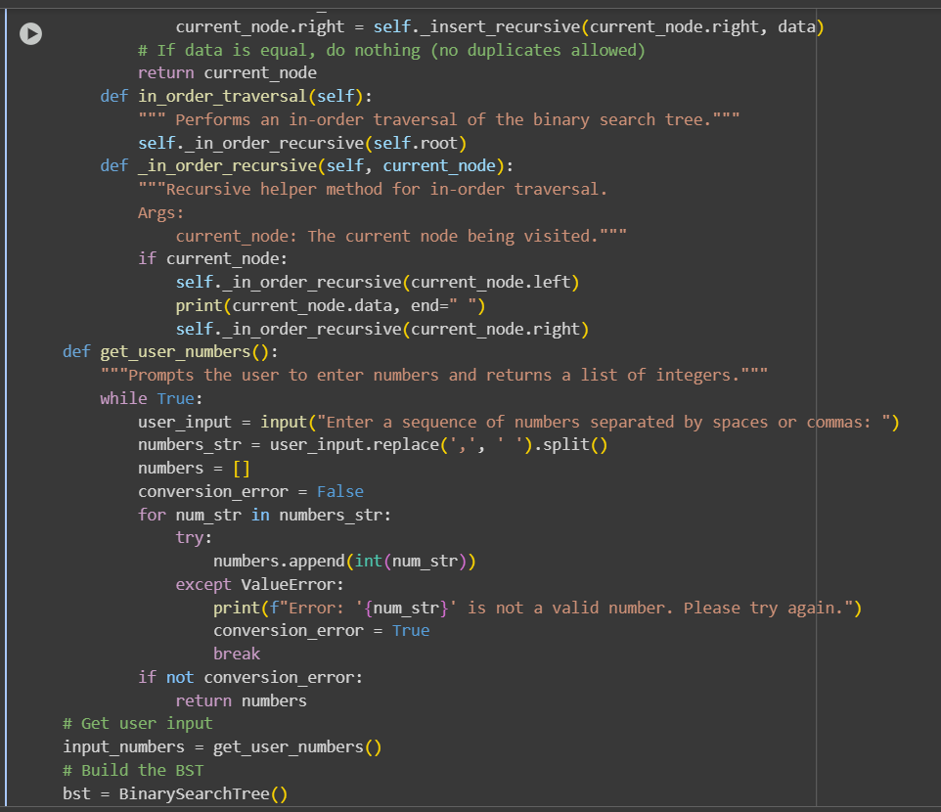  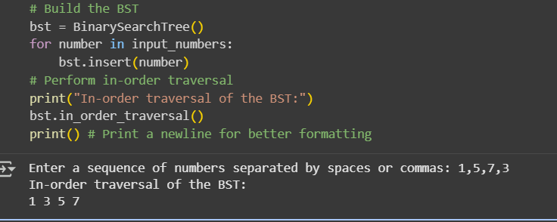  Task Description #5 – Hash Table  Task: Use AI to implement a hash table with basic insert, search, and delete methods.  Sample Input Code:  class HashTable:  pass  Expected Output:  - Collision handling using chaining, with well-commented methods.  Prompt : Write a python code for hash table with basic requirements such as insertion , search and delete methods. The output should consists of collision handling with commented methods  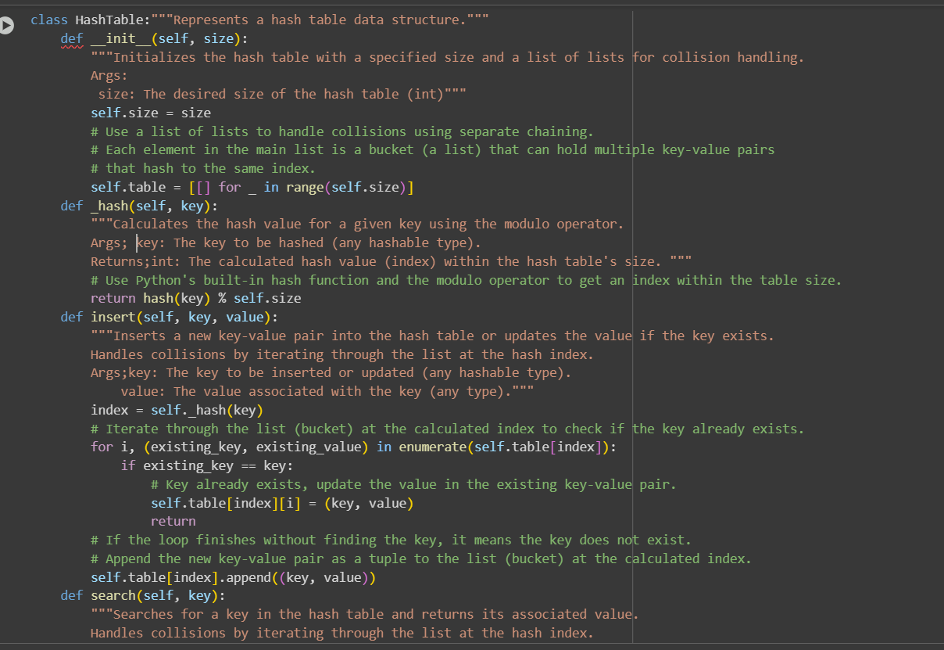  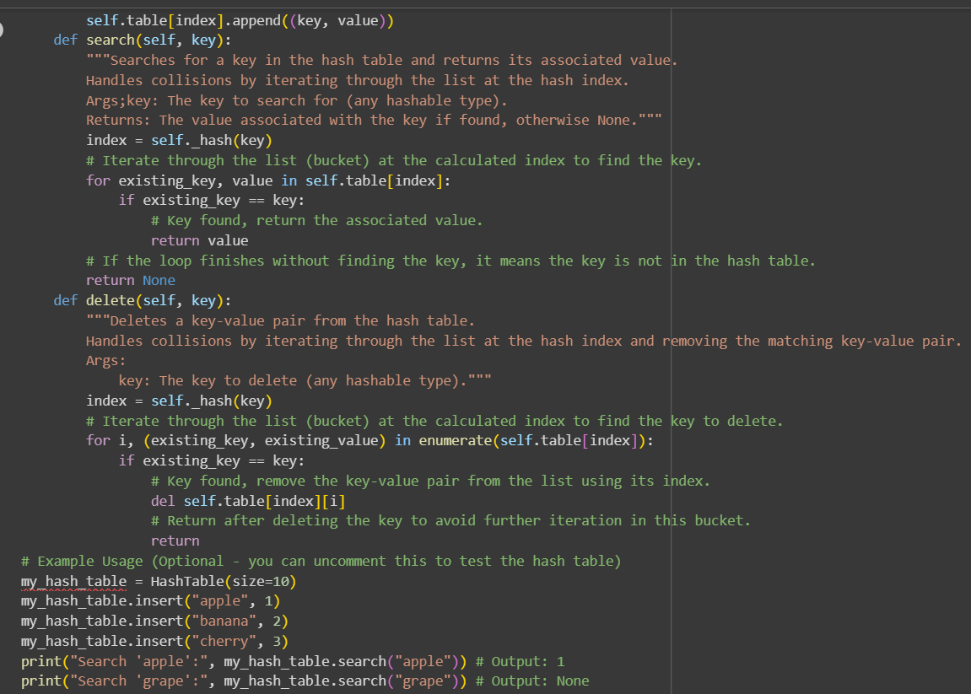  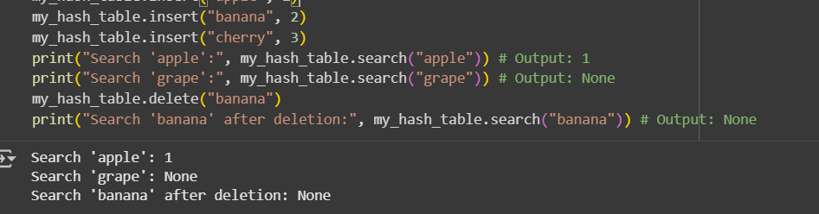  Task Description #6 – Graph Representation  Task: Use AI to implement a graph using an adjacency list.  Sample Input Code:  class Graph:  pass  Expected Output:  - Graph with methods to add vertices, add edges, and display connections.  Prompt : Write a python code to generate a graph using adjacent list . The output should consists the graph with methods to add vertices , add edges and display connections.  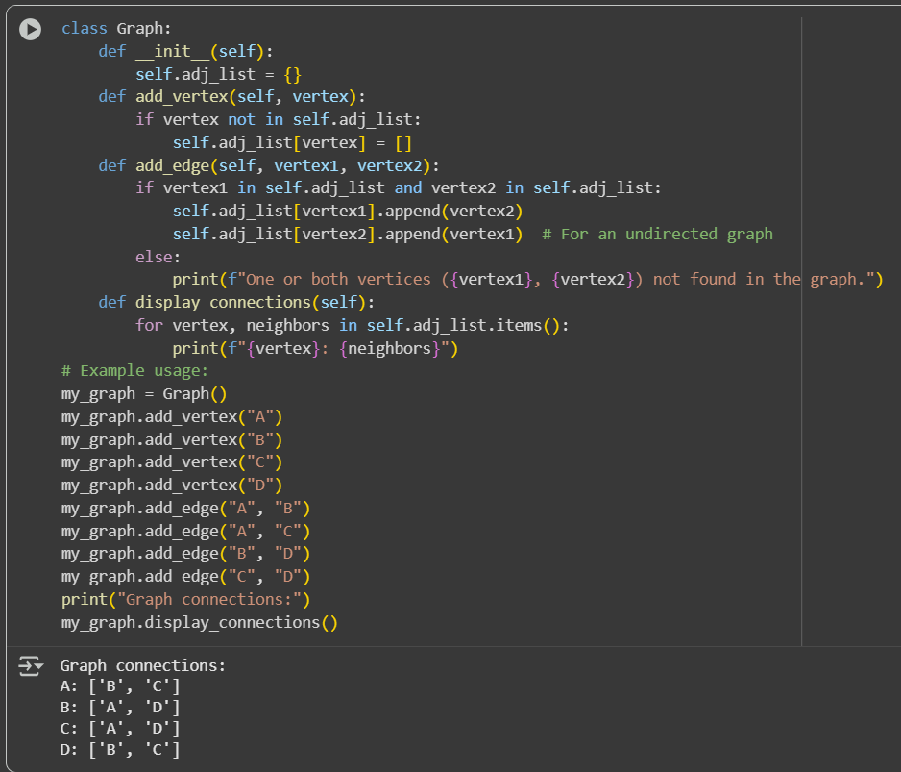  Task Description #7 – Priority Queue  Task: Use AI to implement a priority queue using Python’s heapq module.  Sample Input Code:  class PriorityQueue:  pass  Expected Output:  - Implementation with enqueue (priority), dequeue (highest priority), and display methods.  Prompt : Write a python code to implement priority queue using heapq module. The output should consist of enqueue , dequeue and display methods.  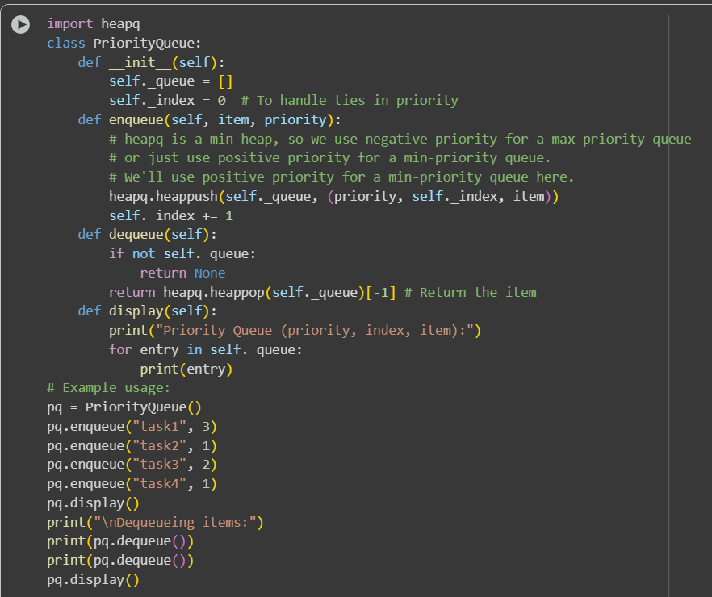  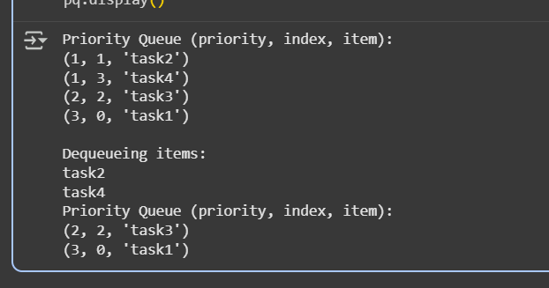  Task Description #8 – Deque  Task: Use AI to implement a double-ended queue using collections.deque.  Sample Input Code:  class DequeDS:  pass  Expected Output:  - Insert and remove from both ends with docstrings.  Prompt : Write a python code which implements a double-ended queue by using the collections . The output should contain insertion and remove from both ends which includes the docstring.  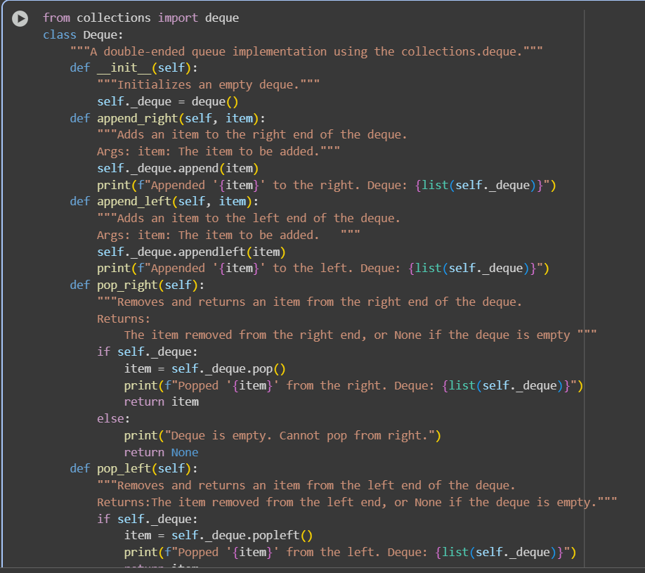  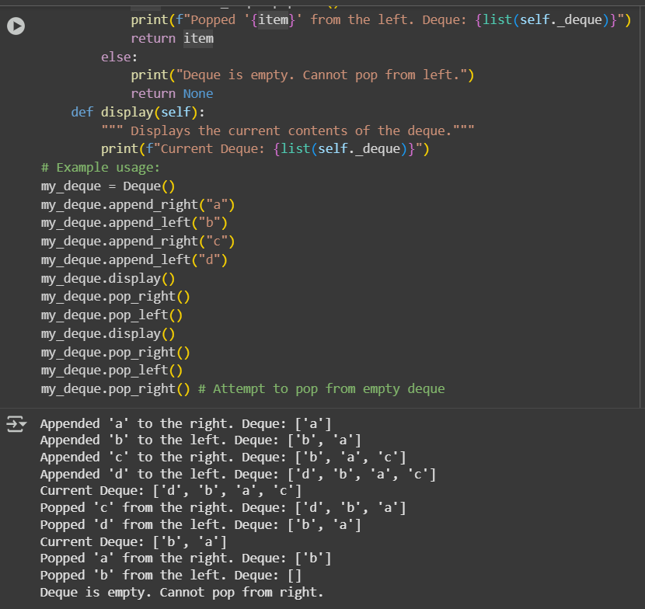  Task Description #9 – AI-Generated Data Structure Comparisons  Task: Use AI to generate a comparison table of different data structures (stack, queue, linked list, etc.) including time complexities.  Sample Input Code:  # No code, prompt AI for a data structure comparison table  Expected Output:  - A markdown table with structure names, operations, and complexities.  Prompt : Write a python code for comparison of a table for diff data structures such as stack , queue, linked list,etc. The output shld consists of structures names , operations and complexities.  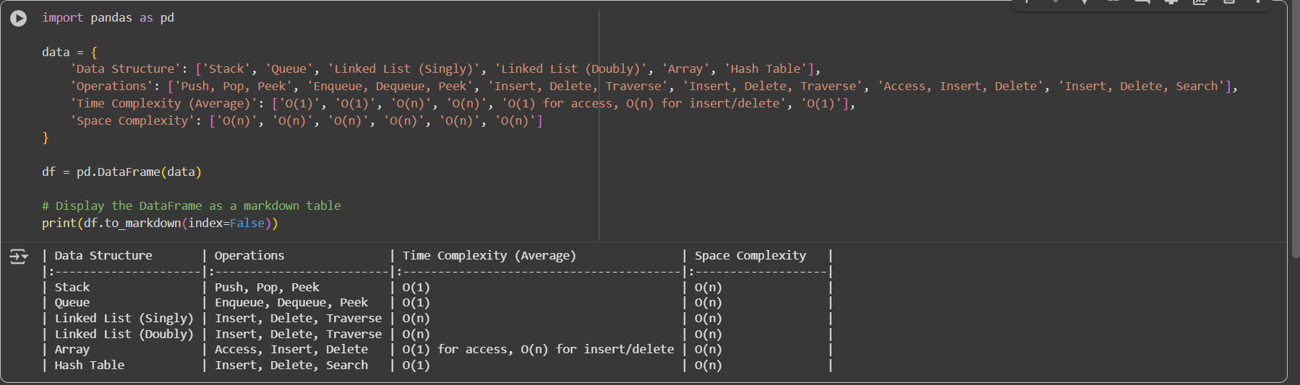  Task Description #10 Real-Time Application Challenge – Choose the Right Data Structure  Scenario:  Your college wants to develop a Campus Resource Management System that handles:  - Student Attendance Tracking – Daily log of students entering/exiting the campus.  - Event Registration System – Manage participants in events with quick search and removal.  - Library Book Borrowing – Keep track of available books and their due dates.  - Bus Scheduling System – Maintain bus routes and stop connections.  - Cafeteria Order Queue – Serve students in the order they arrive.  Student Task:  - For each feature, select the most appropriate data structure from the list below:  - Stack  - Queue  - Priority Queue  - Linked List  - Binary Search Tree (BST)  - Graph  - Hash Table  - Deque  - Justify your choice in 2–3 sentences per feature.  - Implement one selected feature as a working Python program with AI-assisted code generation.  Expected Output:  - A table mapping feature → chosen data structure → justification.  - A functional Python program implementing the chosen feature with comments and docstrings.  Prompt : Write a python code to develop a campus resource management system which handles the following : 1. Student Attendance Tracking – Daily log of students entering/exiting the campus. 2. Event Registration System – Manage participants in events with quick search and removal. 3. Library Book Borrowing – Keep track of available books and their due dates. 4. Bus Scheduling System – Maintain bus routes and stop connections. 5. Cafeteria Order Queue – Serve students in the order they arrive.  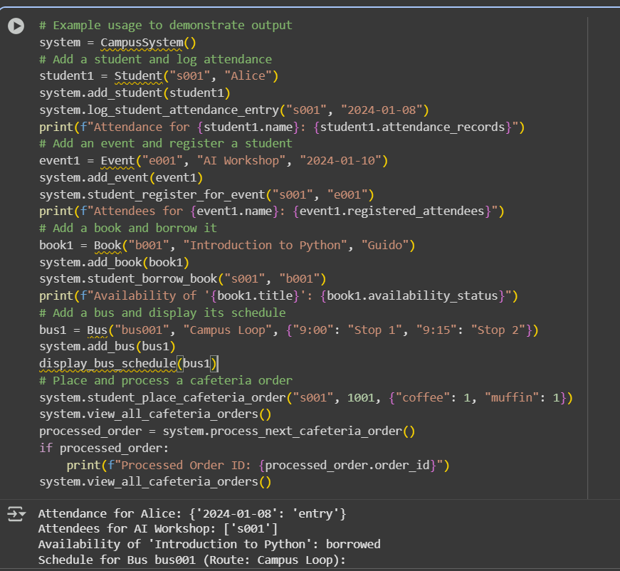  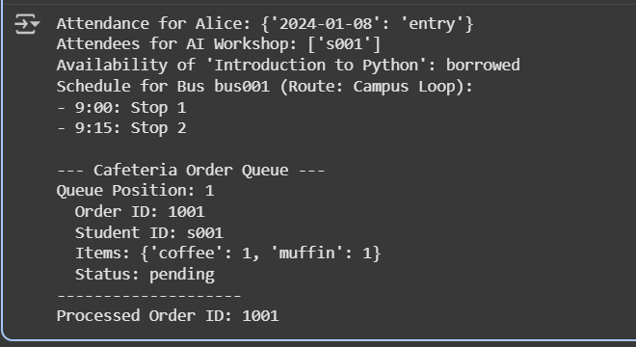  ✅ Deliverables (For All Tasks)  - AI-generated prompts for code and test case generation.  - At least 3 assert test cases for each task.  - AI-generated initial code and execution screenshots.  - Analysis of whether code passes all tests.  - Improved final version with inline comments and explanation.  - Compiled report (Word/PDF) with prompts, test cases, assertions, code, and output. |  |  |  |  |  | Week6 - Monday

